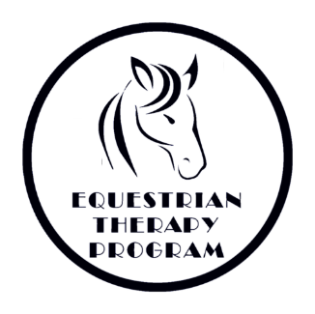
Equine University (Minor)
Rider Information and Health History

Student Name: _________________________________________________________
Parent/Guardian: ________________________________________________________
Address: __________________________________________ City:_______________________
State: ___________ Zip Code: ___________ Email:___________________________________
Phone: _________________________________ Cell:__________________________________
Parent/Guardian address (if different from above): ___________________________________________________________________________
Caregiver: _________________________ Phone: ________________________________
Please contact named individual in the event of a cancellation if different from student’s phone number. Name: ______________________ Phone: ___________________________

Gender: M F DOB: ______________ Weight: ___________ Height: ____________
Allergies and Medications: _______________________________________________________________________________________________________________________________________________________________________________________________________________________________________
Other Health Conditions: ________________________________________________________
___________________________________________________________________________________________________________________________________________________________________________________________________________________________________________________________________________________________________________________

22532 Bowsher Road · Cridersville, Ohio 45806 · Phone (419) 657-2700 · Fax (419) 657-2887

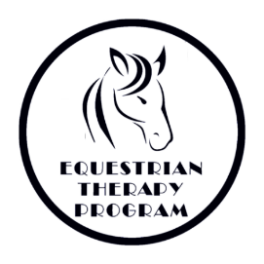
Emergency Medical Consent Form

Students Name: _______________________________________________________________
Parent(s)/Legal Guardian(s): _________________________________________________________________
Physician’s Name: _____________________________________________ Phone: _____________________
Address: _____________________________ City: ___________________ State: ______ Zip: _____________
Preferred Medical Facility: _________________________
Health Insurance Co. ____________________________________ Policy # __________________________
Person who is authorized to give temporary assistance or care in the absence of parent or guardian:
Name: ___________________________________ Phone: __________________ Relation: ______________
Consent
In case of medical emergency, the undersigned authorizes Equestrian Therapy Program to provide such medical assistance as they determine to be necessary,
I hereby give my consent, in the event that all reasonable attempts to contact me have been unsuccessful, to the administration of any treatment deemed necessary by or the transfer to the student to ________________
(preferred hospital) or any hospital reasonably accessible. This authorization does not cover major surgery unless the medical opinions of two other licensed physicians or dentists concur in the necessity to such surgery and are obtained prior to the performance of such surgery.

Date: ___________ Consent Signature: ___________________________________________ (Participant or legal guardian)

Non Consent
I do not give my consent for emergency medical treatment/aid in the case of illness or injury during the process of receiving services or while being on the property or The Equestrian Therapy Program.
__ Parent or Legal Guardian will remain on site at all times during equine assisted activities.
__ In the event emergency treatment/aid is required, I wish the following procedure to take place.
_____________________________________________________________________________
Date: ___________ Non-Consent Signature: ________________________________________(Participant or legal guardian)
Participants under age (18) must have this form signed by a legal guardian

22532 Bowsher Road · Cridersville, Ohio 45806 · Phone (419) 657-2700 · Fax (419) 657-2887
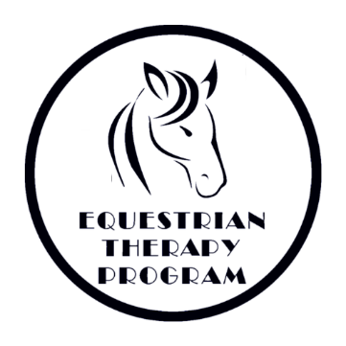

Photo Release Form

I _______________________ give permission for the Equestrian Therapy Program to take still and moving photographs and films, including television pictures, of our son/daughter/ward/self _________________________________________________.
In addition, I consent and authorize the ETP and its advertising agencies, the news media, and any other person or organization interested in the ETP and its work to use and reproduce said photographs, films and pictures, and to circulate and publicize the same by any and all means, including, but not limited to, news-papers, magazines, television, brochures, pamphlets, instructional materials, books, and clinical material.
No inducements or promises have been made to us/me to secure our/my signature(s) to this release other than the intention of the ETP to use said photographs, films and pictures for the primary purpose of promoting and aiding the ETP and its work. The ETP is a nonprofit Ohio corporation.
Date: ___________________
_____________________________ __________________________________
Signature of Witness Signature of Parent(s)/ Guardian
_____________________________ ___________________________________
Signature of Witness Signature of Participant (if over 18)
If you do consent to the above, then this form needs to be signed by the participant, if over age 18, and either by both natural parents, or by the sole parent having legal custody, or by the participant’s legal guardian.
_________________________________________________________________________________________
No Photo
I ___________________________________ do not consent to photos or moving pictures of son/daughter/ward/self.
Date: _____________________
_____________________________ __________________________________
Signature of Witness Signature of Parent(s)/ Guardian
_____________________________ ___________________________________
Signature of Witness Signature of Participant (if over 18)

22532 Bowsher Road · Cridersville, Ohio 45806 · Phone (419) 657-2700 · Fax (419) 657-2887
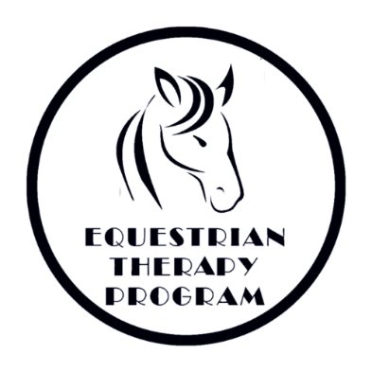

Student Guidelines

- The student must be FOUR years of age and have a minimum sitting balance and head control of a 6-month-old. Students who have had a Gran Mal seizure within the last year may not be eligible for horseback riding.
- Our weight limit for riding is determined by assessment and available equine.
- ALL FORMS MUST BE FILLED OUT, SIGNED and returned to us before the student may ride. No student will be permitted to ride without these forms.
- When riding, the student must be in a sturdy closed-toe shoe, preferably with heels. Long pants are preferred for the rider’s comfort, but are not required. SANDALS/SLIP ON SHOES/CROCS ARE NOT PERMITTED due to the possibility of foot injuries. Approved helmets are required and provided. Please remember to wear hair styles that are conducive to a snug-fitting hard hat. Avoid dangling earrings and other jewelry.
- Please observe all barn rules while at the farm. All family and visitors should stay inside the bleacher/lounge area of the barn unless specifically invited to go to another part of the building.
- Our volunteers give of their time and talent so that you are able to ride. PLEASE let us know AS SOON AS POSSIBLE if you will be unable to attend a class so that we can schedule our volunteers accordingly. We can be reached at 419-657-2700. For cancellations less than 24 hours in advance, please call the office and leave a message if we do not pick up.
- During extreme weather, not conducive to riding, we will provide alternative activities. In the event that travel is not advisable we will cancel classes, see WLIO for cancellations or call the office. We will call you at the numbers you have provided on your forms.
- If a student has TWO UNEXCUSED ABSENCES in a session, we have the right to excuse them from the program. We have a waiting list of students who would like to ride and we value the time our volunteers donate.
- If we determine that this type of riding therapy is not suitable for a student because of safety to the student, volunteer, instructor, horse, or for any other reason, we reserve the right to deny riding to that student.

Thank You for Your Cooperation,
The Equestrian Therapy Program Staff

22532 Bowsher Road · Cridersville, Ohio 45806 · Phone (419) 657-2700 · Fax (419) 657-2887

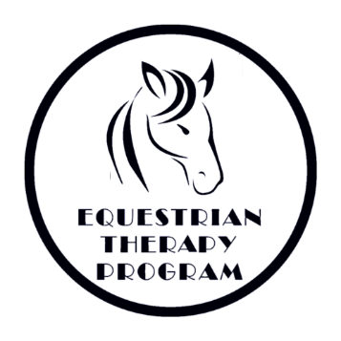

Barn Rules

- Riders must wear a helmet when mounted and working with a horse.
- No chewing gum while mounted.
- Everyone is to walk quietly through the barn, without running.
- Always walk around the head of the horse, not behind.
- Respect all persons, animals and property.
- Students (adults and youths) must always stay with an instructor, volunteer, or teacher when going beyond waiting area.
- Treats can only be fed to the horses with instructor permission and with the help of a volunteer. No feeding from your hand, please only use treat bowls.
- Students must wear sturdy closed-toed shoes. Sandals/slip on shoes/crocs are not permitted.
- Indoor voices and appropriate language must be used at all times.
- Pet the horses on the neck or shoulder – not the face. Approach them in a slow quiet manner.
- Listen to the instructor and follow directions carefully.
- Staff, volunteers, and participants will silence their cell phones during equine assisted activities and/or while handling equines. Under no circumstances will staff, volunteers, or participants answer their cell phones during equine assisted activities or while handling equines.

22532 Bowsher Road · Cridersville, Ohio 45806 · Phone (419) 657-2700 · Fax (419) 657-2887

EXPRESS ASSUMPTION OF RISK, RELEASE OF LIABILITY, WAIVER OF CLAIMS AND INDEMNITY AGREEMENT (Minor Child)
This Express Assumption of Risk, Release of Liability and Waiver of Claims (the “Agreement”) is entered into by the undersigned, as individuals and as the parents and/or legal guardians for the minor child (the “Minor Child” as printed above), in favor of The Equestrian Therapy Program and their employees and independent contractors (“Providers”). In consideration for the Minor Child being permitted to participate in Equine Activities, including, but not limited to equine assisted psychotherapy and learning activities and otherwise handling equines, we acknowledge and agree as follows:

- Dangerous Activity: We acknowledge that horses, ponies, and other equines can be unpredictable animals and fully realize that there are dangers and risks inherent in Equine Activities, including but not limited to:
- The propensity of an equine to behave in ways that may result in injury, death, or loss to persons on or around the equine;
- The unpredictability of an equine’s reactions to sounds, sudden movement, unfamiliar objects, persons or other animals;
- Hazards, including but not limited to surface or subsurface conditions or weather;
- A collision with another equine, another animal, a person or an object; and
- The potential of an Equine Activity Participant to act in a negligent manner that may contribute to injury, death, or loss to the person of the Participant or to other persons, including but not limited to, failing to maintain control over an equine or failing to act within the ability of the Participant.
We understand that neither the actions of the Minor Child, nor the actions of any person or animal can necessarily be controlled, and that the Minor Child’s safety and that of our and the Minor Child’s property cannot be guaranteed while participating in Equine Activities. We understand and have discussed these risks with the Minor Child who understands them to the extent possible given his/her age and abilities, and who wishes to participate in Equine Activities despite the risk.
We, too, wish for the Minor Child to participate in Equine Activities despite the risk.
We also acknowledge that we have had the opportunity to inspect the equipment and real property of Stable and find the same to be acceptable. We further acknowledge that the Minor Child has sufficient ability to engage in Equine Activities of the kind provided by Providers.
- Assumption of Risks: Understanding the risks involved, we voluntarily choose to allow the
Minor Child to participate in Equine Activities and EXPRESSLY ASSUME THE ASSOCIATED RISKS, INCLUDING THE RISK OF INJURY AND DEATH, WHETHER CAUSED BY THE UNINTENTIONAL NEGLIGENCE OF THE PROVIDERS OR ANY OTHER CAUSE. We accept full
and complete responsibility for the safety of the Minor Child, ourselves, any guests or observers, and our personal property.
- Release and Waiver of Claims: On behalf of the Minor Child, ourselves, our and his/her heirs, successors in interest, guardians, legal representatives and assigns, WE HEREBY RELEASE AND FOREVER DISCHARGE THE STABLE FROM ALL CLAIMS, ACTIONS, DEMANDS, RIGHTS, CAUSES OF ACTION AND LIABILITY, IN LAW OR IN EQUITY, BASED UPON ANY BODILY INJURY OR DISABILITY, ILLNESS OR DISEASE, DEATH, FINANCIAL LOSS, PROPERTY DAMAGE OR LOSS, OR OTHER HARM OF WHATEVER NATURE, WHETHER FORESEEN OR UNFORESEEN, THAT MAY BE SUSTAINED OR SUFFERED BY OUR MINOR CHILD, OURSELVES, OR BY ANY OTHER PERSON AS A DIRECT OR INDIRECT CONSEQUENCE OF OUR MINOR CHILD’S PARTICIPATION IN EQUINE ACTIVITIES OR BY HIS/HER PRESENCE IN EQUINE ACTIVITIES WITH THE STABLE, WHETHER CAUSED BY THE UNINTENTIONAL NEGLIGENCE OF THE PROVIDERS OR OTHERWISE.
- Promise Not to Bring Suit: We hereby agree and promise that we, our heirs, successors in interest, guardians, legal representatives and assigns will not bring a claim against, sue, demand compensation from or attach the property or assets of the Providers, either on our own behalf, or on behalf of the Minor Child or any other person, for any loss or damage arising or resulting directly or indirectly from our Minor Child’s participation in Equine Activities with the Providers.

Ohio Equine Activity Statute: We understand that Title XXIII, Chapter 2305, Section (B)(1) of the Ohio Revised Code provides in part, that, “…An equine activity sponsor, equine activity participant, equine professional,…or other person is not liable in damages in a tort or other civil action for harm that an equine activity participant allegedly sustains during and equine activity and that results from an inherent risk of an equine activity. …An equine activity participant or the personal representative of an equine activity participant does not have a claim or cause of action upon which a recovery of damages may be based against, and may not recover damages in a tort or other civil action against, an equine activity sponsor, another equine activity participant, and equine professional, …or another person for harm that the equine activity participant allegedly sustained during an equine activity ant that resulted from an inherent risk of equine activity.”

- Full Understanding: We hereby warrant that:
- WE HAVE VOLUNTARILY ENTERED INTO THIS AGREEMENT OF OUR OWN FREE WILL, WITHOUT DURESS OR PRESSURE FROM ANY PERSON; and
- WE UNDERSTAND AND ACKNOWLEDGE THAT BY SIGNING THIS AGREEMENT WE ARE GIVING UP CERTAIN LEGAL RIGHTS, INCLUDING THE RIGHT TO RECOVER DAMAGES IN CASE OF INJURY, DEATH OR PROPERTY DAMAGE. WE UNDERSTAND THAT THIS DOCUMENT IS A PROMISE NOT TO SUE.
- Choice of Law, Jurisdiction: The terms of this agreement shall be governed by and interpreted according to the law of the State of Ohio, the courts of which shall have exclusive jurisdiction over any matter arising hereunder.

- Severability: We agree that this document is intended to be as broad and inclusive as permitted by Ohio law. If any portion of the Agreement is determined to be invalid, illegal or unenforceable, that portion shall be severable, and the validity, legality and enforceability of the balance of the Agreement shall not be affected or impaired in any way and shall continue in full force and effect.
I HAVE READ THIS ENTIRE AGREEMENT (2 pages) CAREFULLY. I FULLY UNDERSTAND ALL OF ITS TERMS AND CONDITIONS. MY SIGNATURE BELOW IS ACKNOWLEDGEMENT THAT I HAVE HAD AN OPPORTUNITY TO CAREFULLY READ THE ENTIRE AGREEMENT AND TO HAVE ANY QUESTIONS ANSWERED TO MY SATISFACTION.

Signature of Parent or Legal Guardian: Date:

Print Name of Minor:

